**SQL JOINS**

**EMPLOYEES TABLE**

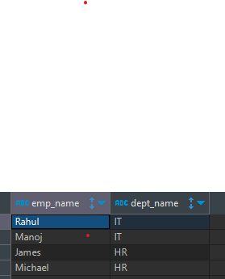**DEPARTMENT TABLE**

**PROJECTS TABLE**

**MANAGER TABLE**

**INNER JOIN**

-- Fetch the employee name and the department name theybelong to.

-- inner join / JOIN

**SELECT** e.emp_name ,d.dept_name

**FROM** employees e **inner** **join** department d **on** e.dept_id = d.dept_id ;

**LEFT JOIN**

-- Fetch ALL the employee name and their department name theybelong to.

-- left join

**SELECT** e.emp_name ,d.dept_name

**FROM** employees e **left** **join** department d **on** e.dept_id = d.dept_id ;

-- left join = inner join + any additional records in the left table.

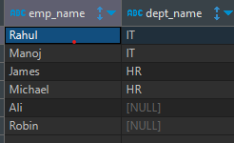

**RIGHT JOIN**

-- right join

**SELECT** e.emp_name ,d.dept_name

**FROM** employees e **right** **join** department d **on** e.dept_id = d.dept_id ;

-- right join = inner join + any additional details in the right table

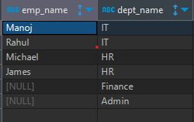

-- Fetch ALL the employees, their manager, their departmentand the projects they work on.

**SELECT** e.emp_name, d.dept_name, m.manager_name, p.project_name

**from** employees e

**left** **join** department d **on** e.dept_id = d.dept_id

**inner** **join** managers m **on** m.manager_id = e.manager_id

**left** **join** projects p **on** p.team_member_id = e.emp_id ;

